SUN VALLEY INTERNATIONAL SCHOOL
A-1, Sector-1,Vaishali,Ghaziabad

A PROJECT REPORT ON
HOTEL MANAGEMENT SYSTEM

SUBMITTED TO SUBMITTED BY:
MS.DEEPTI GUPTA CHAKSHITA SHARMA
P.G.T(COMP.SC) DISHI GAUTAM
JIYA SINGH

CERTIFICATE
This is to certify that CHAKSHITA SHARMA,
DISHI GAUTAM, JIYA SINGH of class XII of Sun
Valley International School has done her project on
HOTEL MANAGEMENT under my supervision. She has taken interest and has shown utmost sincerity in completion of this project.
I certify this Project up to my expectation & as per
Guidelines issued by CBSE.

Internal Examiner External Examiner

Principal

ACKNOWLEDGEMENT

It is with pleasure that I acknowledge my sincere gratitude to our teacher, Ms. Deepti Gupta who taught and undertook the responsibility of teaching the subject computer science. I have been greatly benefited from her classes.
I am especially indebted to our Principal Ms. Preeti Goel who has always been a source of encouragement and support and without whose inspiration this project would not have been a successful. I would like to place on record heartfelt thanks to her.
Finally, I would like to express my sincere appreciation for all the other students for my batch their friendship & the fine times that we all shared together.

INDEX
S.No. | Topic | Page  No.
1 | Project Synopsis | 5
2 | Requirements | 7
3 | References | 8
4 | General Information | 9
5 | Tables | 10
6 | Source Code | 11
7 | Output Screen | 27

PROJECT SYNOPSIS
Title of the Project:
Hotel Management
Definition:
Design a Project to analyse the data set of a Hotel and calculate Total bill of a customer,displaying the Customer data from a particular table, deleting a record, searching a specific record. The customer id is used to find the customer details i.e. Name, phone, ID proof, check in and check out.
This project is made to make the work of Hotel management easy to find out the details of a particular customer management and can easily calculate the total bill of customers.
Contribution / Team members:
- Chakshita Sharma
- Dishi Gautam
- Jiya Singh

Team Detail:
The Project Hotel management is developed by Chakshita Sharma, Dishi Gautam and Jiya Singh, it took approx. 15 days to develop this project,working 1.5 Hours daily. All modules
completed by the three of us only as per our views and knowledge.
Reason for choosing the Topic:
Because every year there are a lot of records of customers, such a huge amount of data is to be stored and calculated, it has to be analyzed by the management either manually or using calculator, then and calculating Total bills or extra facilities provided by the hotel analysis is a tedious and tiring job for management . Some receptionists make these calculations on the spreadsheets etc after data alignment from text file to excel sheet, which is really a tiring job. That is why to simplify their task, to give them relief from manual work, and to minimize their burden, we took the challenge and started working with this project to automate their job using Python programming.
Objective:
To analyze the data set of Hotel
To Calculate Total bill of a customer
To display the customer data for a particular table
To delete data or records
To insert any data
To search for a particular record

Requirements:
A Computer/Laptop with
Operating System-Windows 7 or above
x86 64-bit CPU (Intel / AMD architecture)
4 GB RAM.
5 GB free disk space.
Software Requirements:
Python 3.6.x or higher version
Ms-Office installed
Limitations:
1- It is not web based project
2- Needs more customization to fulfill the need of every hotel.
3- More functionality can be added as per requirement.
4- No provision to print hard copies.

References / Bibliography:
- Online Python documentation - for python command syntax
- Text book - Class XI and XII - Informatics Practices NCERT
- Class notes
- Computer Science With Python (Preeti Arora)
- www.google.com

GENERAL INFORMATION

DATABASE NAME: HOTEL

NUMBER OF TABLES-5
- CUST_DETAILS
- BOOKING
- ROOM_SERVICES
- ROOMTYPE
- RESTAURANT

TABLES
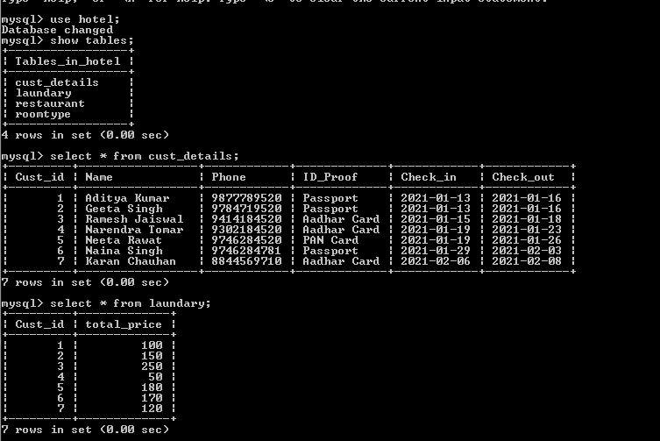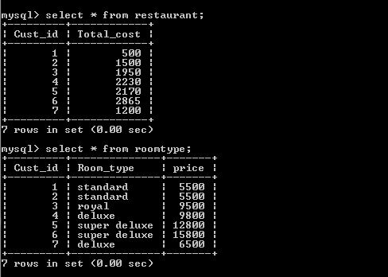

SOURCE CODE
INSERTION
def cust_details():
import mysql.connector
myconn=mysql.connector.connect(host='localhost',user='root'
,passwd=' ',database='hotel')
cur=myconn.cursor()
cust_id=int(input("Enter Customer ID:"))
name=input('Enter Customer Name: ')
phone=input('Enter Customer Phone: ')
id=input('Enter ID Proof provided by Cutomer: ')
email=input('Enter Email ID: ')
cur.execute('insert into
cust_details values("%d","%s","%s","%s","%s")'%
(cust_id,name,phone,id,email))
print('Record Added Successfully')
myconn.commit()
cur.close()

---------------------------------------------------------------------------------------------------------------------------------------------------
def booking_date():
import mysql.connector
myconn=mysql.connector.connect
(host='localhost',user='root',passwd=' ',database='hotel')
cur=myconn.cursor()
cust_id=int(input("Enter Customer ID:"))
check_in=input('Enter check in date(YYYY-MM-DD): ')
check_out=input('Enter check out date(YYYY-MM-DD): ')
cur.execute('insert into booking_date values
("%d","%s","%s")'%(cust_id,check_in,check_out))
print('Record Added Successfully')
myconn.commit()
cur.close()
---------------------------------------------------------------------------------------------------------------------------------------------------
def room_type():
import mysql.connector
myconn=mysql.connector.connect
(host='localhost',user='root',passwd=' ',database='hotel')
cur=myconn.cursor()
cust_id=int(input("Enter Customer ID:"))
print("-----We have The Following Room Categories-----")
print("1.Standard: Rs.2500/-")
print("2.Deluxe room: Rs.5000/-")
print("3.Super Deluxe room: Rs.8000/-")
print("4.Royal suite: Rs.10000/-")
r=int(input('Enter Your Room Choice: '))
room=int(input('Enter Room Number: '))
n=int(input('Enter Number of Days: '))
if r==1:
rent=n*2500
print('Your Room Rent For Standard room: ',rent)
elif r==2:
rent=n*5000
print('Your Room Rent For Deluxe room: ',rent)
elif r==3:
rent=n*8000
print('Your Room Rent For Super Deluxe: ',rent)
elif r==4:
rent=n*10000
print('Your Room Rent For Royal Suite: ',rent)
else:
print('Wrong input')
query='insert into roomtype values ("%d","%d","%d","%d","%d")'%(cust_id,r,room,n,rent)
cur.execute(query)
myconn.commit()
print('Record Added Successfully')
---------------------------------------------------------------------------------------------------------------------------------------------------
def room_services():
import mysql.connector
myconn=mysql.connector.connect
(host='localhost',user='root',passwd=' ',database='hotel')
cur=myconn.cursor()
print('1.Laundary (with ironing): Rs40/-')
print('2.Room Cleaning: Rs150/-')
s=int(input('Enter your choice: '))
cust_id=int(input("Enter Customer ID:"))
bill=0
if s==1:
n=int(input('Enter number of clothes: '))
bill+=40*n
print('Your Laundary bill for',n,' clothes is ',bill)
elif s==2:
bill+=150
print('Your Room Cleaning bill is: ',bill)
else:
print('Invalid input')
cur.execute('insert into room_services values("%d","%d","%d")'%(cust_id,s,bill))
print('Record entered successfully')
myconn.commit()
cur.close()
---------------------------------------------------------------------------------------------------------------------------------------------------
def restaurant_insert():
import mysql.connector
myconn=mysql.connector.connect(host='localhost',user='root',passwd=' ',database='hotel')
cur=myconn.cursor()
print('-----BELOW IS THE PRICE FOR AN INDIVIDUAL-----')
print('1. Breakfast: Rs200/-')
print('2. Lunch/Dinner: Rs350/-')
n=int(input('Enter your choice: '))
custid=int(input('Enter Customer ID: '))
s=int(input('Enter number of persons: '))
t=int(input('Enter the times meal taken: '))
if n==1:
p=200*s*t
print('Your Bill: ',p)
elif n==2:
p=350*s*t
print('Your Bill: ',p)
else:
print('Invalid Input')
cur.execute('insert into restaurant values("%d","%d","%d")'%(custid,n,t))
myconn.commit()

------------------------------------------------------------------------------------------------------------------------------------------------------------------------------------------------------------------------------------------------------------------------------------------------------
DISPLAYING
def cust_display():
import mysql.connector
myconn=mysql.connector.connect
(host='localhost',user='root',passwd=' ',database='hotel')
cur=myconn.cursor()
cur.execute('select * from cust_details')
for i in cur:
print(i)
cur.close()
---------------------------------------------------------------------------------------------------------------------------------------------------
def booking_display():
import mysql.connector
myconn=mysql.connector.connect
(host='localhost',user='root',passwd=' ',database='hotel')
cur=myconn.cursor()
cur.execute('select * from booking_date')
for i in cur:
print(i)
cur.close()

---------------------------------------------------------------------------------------------------------------------------------------------------
def room_display():
import mysql.connector
myconn=mysql.connector.connect
(host='localhost',user='root',passwd=' ',database='hotel')
cur=myconn.cursor()
cur.execute('select * from room_services')
for i in cur:
print(i)
cur.close()
---------------------------------------------------------------------------------------------------------------------------------------------------
def roomtype_display():
import mysql.connector
myconn=mysql.connector.connect
(host='localhost',user='root',passwd=' ',database='hotel')
cur=myconn.cursor()
for i in cur:
print(i)
cur.close()

---------------------------------------------------------------------------------------------------------------------------------------------------
def restaurant():
import mysql.connector
myconn=mysql.connector.connect
(host='localhost',user='root',passwd=' ',database='hotel')
cur=myconn.cursor()
cur.execute('select * from restaurant')
for i in cur:
print(i)
cur.close()

DELETE
def delete():
import mysql.connector
myconn=mysql.connector.connect
(host='localhost',user='root',passwd=' ',database='hotel')
cur=myconn.cursor()
custid=int(input('Enter Customer ID: '))
print("""1: DELETE FROM CUSTOMER DETAILS2: DELETE FROM BOOKING\n3: DELETE FROM ROOM_TYPE\n4: DELETE FROM RESTAURANT\n5: DELETE FROM ROOM_SERVICES\n""")
ch=int(input("Enter the choice of the table from you want to delete the record:"))
if ch==1:
cur.execute('delete from booking_date where Cust_id="%d"'%custid)
print('Record Deleted')
elif ch==2:
cur.execute('delete from roomtype where Cust_id="%d"'%custid)
print('Record Deleted')
elif ch==3:
cur.execute('delete from restaurant where Cust_id="%d"'%custid)
print('Record Deleted')
elif ch==4:
cur.execute('delete from room_services where Cust_id="%d"'%custid)
print('Record Deleted')
else:
print('Invalid Input')
myconn.commit()
cur.close()

------------------------------------------------------------------------------------------------------------------------------------------------------------------------------------------------------------------------------------------------------------------------------------------------------
DISPLAYING A SPECIFIC RECORD

def search():
import mysql.connector
myconn=mysql.connector.connect
(host="localhost",user="root",passwd=" ",database="hotel")
cur=myconn.cursor()
r=int(input("Enter Customer ID: "))
print('a.''Customer Details')
print('b.''Booking Date')
print('c.''Restaurant')
print('d.''Roomtype')
print('e.''Room Services')
u=input('Enter your choice: ')
if u=='a':
cur.execute("select * from cust_details where Cust_id='%d'" %r)
print('Cust_id Name Phone ID_Proof Email')
for i in cur:
print(i)
elif u=='b':
cur.execute("select * from booking_date where Cust_id='%d'"%r)
print('Cust_id Check_in Check_out')
for j in cur:
print(j)
elif u=='c':
cur.execute("select * from restaurant where Cust_id='%d'" %r)
print('Cust_id Choice Meal_occurence')
for k in cur:
print(k)
elif u=='d':
cur.execute("select * from roomtype where Cust_id='%d'" %r)
print('Cust_id Room_type Room_no Days Total')
for l in cur:
print(l)
elif u=='e':
cur.execute("select * from room_services
where Cust_id='%d'"%r)
print('Cust_id Service Total')
for m in cur:
print(m)
else:
print('Invalid input')
----------------------------------------------------------------------------------------------------------------------------------------------------------------------------------------------------------------------------------------------------
TOTAL
def TotalBill():
import mysql.connector
myconn=mysql.connector.connect
(host='localhost',user='root',passwd=' ',database='hotel')
cur=myconn.cursor()
n=int(input('Enter Customer ID: '))
cur.execute('select Name from cust_details
where Cust_id="%d"'%n)
for x in cur:
print(' Customer Name: ',str(x))
cur.execute('select Total from roomtype where Cust_id="%d"'%n)
for y in cur:
print(' Room Rent: ',str(y))
cur.execute('select Total from room_services
where Cust_id="%d"'%n)
for z in cur:
print(' Room Service Bill: ',str(z))
cur.execute('select Choice,Meal_occurence from restaurant where Cust_id="%d"'%n)
for a in cur:
if a[0]==1:
s=int(a[1])*200
print(' Restaurant Bill: ',s)
T=int(y)+int(z)+s
print('TOTAL BILL: ',T)
elif a[0]==2:
r=int(a[1])*350
print(' Restaurant Bill: ',r)
print('TOTAL BILL: ',T)
print('-------------------------------------')
print(" Thank You Visit Again :) ")

------------------------------------------------------------------------------------------------------------------------------------------------------------------------------------------------------------------------------------------------------------------------------------------------------

print('-------WELCOME TO HOTEL TRANSYLVANIA------')
print('1.INSERTION OF RECORD')
print('2.DISPLAY RECORDS')
print('3.DELETE A RECORD')
print('4.TOTAL BILL')
choice=int(input('Enter your choice: '))
if choice==1:
print(' Kindly enter record to Customer details first ')
cust_details()
print('a.''To add record in Booking table')
print('b.''To add record in Restaurant table')
print('c.''To add record in Roomtype table')
print('d.''To add record in Room Service table')
s=input('Enter your choice:')
if s=='a':
booking_date()
elif s=='b':
restaurant_insert()
elif s=='c':
room_type()
elif s=='d':
room_services()
else:
print('Invalid Input')
elif choice==2:
print('a.''To display Customer Details')
print('b.''To display Booking date')
print('c.''To display Restaurant record')
print('d.''To display Roomtype record ')
print('e.''To display Room Service record')
a=input('Enter your choice: ')
if a=='a':
cust_display()
elif a=='b':
booking_display()
elif a=='c':
restaurant_display()
elif a=='d':
roomtype_display()
elif a=='e':
room_display()
else:
print('Invalid Input')
elif choice==3:
delete()
elif choice==4:
TotalBill()
else:
print('Invalid Input')

OUTPUT SCREENS

1.INSERTION OF RECORD
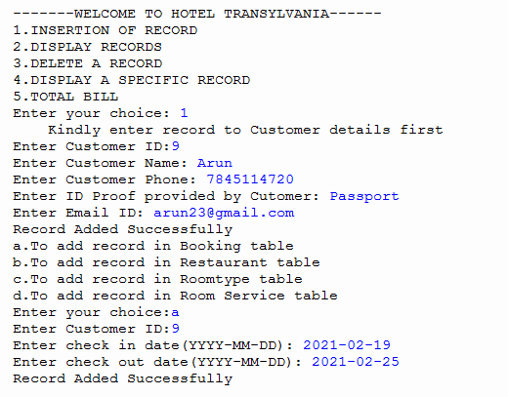

2.DISPLAYING RECORDS
.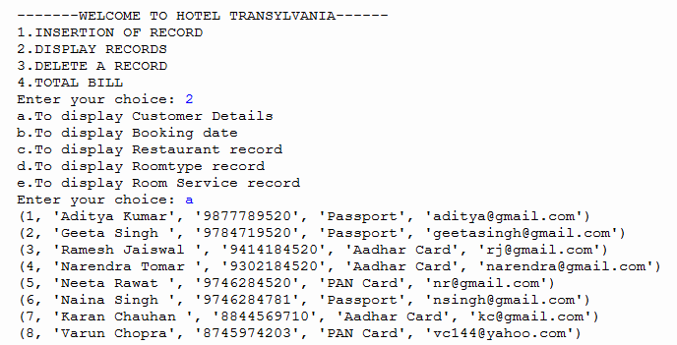
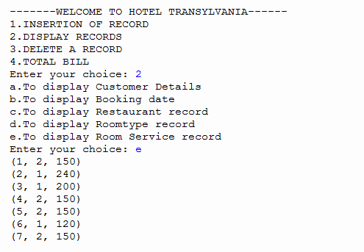

3.DELETION OF RECORDS
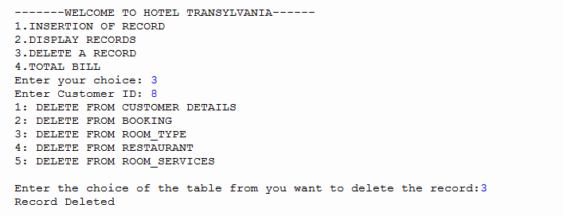
4.DISPLAYING A SPECIFIC RECORD

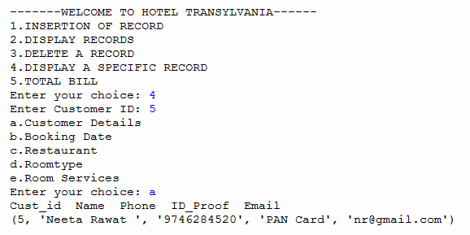

5.TOTAL BILL
